**Full Title:**Digitizing a Statewide Map of Community Water System Service Areas

**Short Title for Running Head:**WaterService Map Digitization

**Authors*:*** Rachel Gonsenhauser, Katy Hansen, Walker Grimshaw, Jannette Morris, Klaus Albertin, and Megan Mullin

**Key Takeaways**

* A statewide digital map of water system service area boundaries allows for improved planning at all levels of government.
* The process for digitizing maps is time-consuming and requires nuance, especially because the input from different systems varies.
* Creating an individual map of their service area can be challenging for low capacity systems. Providing assistance to these systems is thus essential.
* Partnerships are key. Acquiring individual maps from system managers and maintaining the data over time requires close partnerships.

**Recommendations for Title Page Art**

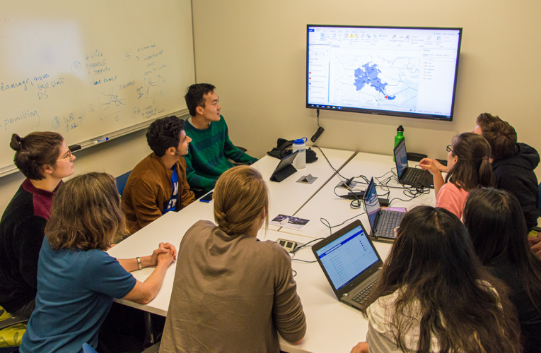

Source: Nicholas Institute for Environmental Policy Solutions

# Introduction

Providing adequate, safe, and reliable drinking water service at an affordable price requires knowledge of how physical, demographic, and financial drivers affect the water system. Accurate information regarding the boundaries of a system’s service area is necessary for assessing these drivers. With maps of service area boundaries, planners can downscale climate models to forecast hazards to infrastructure and water quality from flooding and drought. By merging service area boundaries with Census data to forecast changes in population and income, planners and water system managers can project demand and the capacity of residents to pay for service. Beyond planning and forecasting for individual systems, a statewide digital map of water service areas facilitates state and regional planning and regulatory and financial oversight. It enables state-level decision making for emergency management, regionalization, and consolidation. Despite these many benefits, only about 15 states across the country currently have publicly available digital maps of water system service areas.

Our team created a set of over 500 digital maps of publicly owned water systems across North Carolina. This article explains the process of digitization, the challenges and constraints, and lessons learned through the creation of this statewide map of service areas. We relied on a strong partnership between Duke University and the North Carolina Department of Environmental Quality’s Division of Water Resources (DWR). DWR provided system maps directly to the Duke team and offered guidance. A team of Duke students developed a systematic process of digitization, data management, and quality control to create individual maps in a consistent manner and combine them into a statewide map.

Creating a statewide map of service areas presents many challenges. Data about service areas are often not available: in North Carolina, 20% of water systems do not have a map of the area they serve. For those that do exist, maps of individual systems are often kept in formats that are often difficult to access and interpret. Some were hand-drawn, while others had no scale or meaningful legend. Other challenges to creating a statewide map of service areas include lack of technical capacity, changing system boundaries, and sensitivity of systems to issues regarding security (Gibson and Pieper 2017). However, overcoming these challenges to map the boundaries of water system service areas is vital to assessing water system vulnerabilities.

# Process of digitization

## Map collection and digitization

Creating a statewide digital map must begin with collection of service area boundary maps from individual water systems. Our team found that working with a state partner that has close relationships with the water systems and statutory responsibility was essential in the collection of individual system maps. In North Carolina, water systems that are publicly owned or serve populations of 3,000 or higher are required to submit maps of their service areas to the DWR as per a drought preparedness act, North Carolina [General Statute §143-355(l)](https://www.ncleg.gov/enactedlegislation/statutes/html/bysection/chapter_143/gs_143-355.html), passed in 2008. Due to this statutory mandate, the DWR acquired maps of service area boundaries for over 500 community water systems across the state, which streamlined the collection process. In an effort to fill gaps and check on map updates since submission, the research team carried out a Web and phone search for current maps for all systems in the state’s 20 largest counties. Results from the search did not substantially expand coverage or produce more current maps than those provided by DWR.

The individual system maps varied widely in content, type, and quality. As summarized in Table 1, maps usually showed the boundaries of a water system’s service area, the location of its water lines, the boundaries of the incorporated municipality served by the system, or some combination thereof. While some systems (13%) sent shapefiles to the DWR, most systems sent analog maps as scanned PDFs. Some had hand-drawn boundary extents or showed highlighted roads to indicate where the water lines run. In 11% of individual system maps, the data were unusable due to insufficient information, poor file resolution, or inability to open the file received.

[INSERT TABLE 1 ABOUT HERE]

Our team developed a standardized procedure to aggregate individual system maps into a geospatially-referenced statewide shapefile in ArcGIS, as described in Table 1. In cases where the data for individual systems came from an analog map, we digitized the information by loading an image of the entire map into ArcGIS. If the map displayed a service area boundary, the boundary line was traced to form the service area extent shapefile and geolocated by utilizing ArcGIS georeferencing techniques, using roads and incorporated places for reference. The procedure for digitizing water lines is shown in Figure 1. We first digitized an image of isolated water lines and then used land parcel data to identify parcels located less than 250 feet from each water line, producing an estimate of the service area that assumes water service to parcels adjacent to water lines. In cases where the map received by our team showed a municipal boundary as the service area extent, or in cases where the population served was less than 500 people, we isolated municipal boundaries from statewide Census data to create service area extent shapefiles. Occasionally, these techniques were combined, as we attempted to apply an appropriate digitization technique to each unique case. For example, our team chose to extend some Census municipal boundaries by merging them with parcels within 250 feet of water lines that went beyond the municipal limits.

[INSERT FIGURE 1 ABOUT HERE]

## Data management and quality control

In order to keep a systematic and replicable record of our digitization process, our team developed comprehensive metadata for the maps we received and digitized. We were careful to ensure that the categories used to organize our metadata were mutually exclusive and collectively exhaustive. The metadata included the system name, the type of file of the original map received, and the type of map following digitization (e.g. service area map or water lines map). Our careful process tracking allowed us to check and redigitize earlier maps as we improved our methods and developed new procedures.

In developing a process of digitization and data management, our team at Duke University and the DWR faced many challenges, primarily those of missing data and variability in data received. Even given the statutory requirement in North Carolina to submit water supply plans accompanied by system maps, 13% of the community water systems owned by a local government have forgone providing a map to DWR. Informed by our state agency partner’s knowledge of North Carolina water service patterns, we used municipal boundaries from the Census TIGER lines to create service area extents for about half of the cases in which we did not receive a map or the map had insufficient information but served an incorporated place. In some cases, individual system maps displayed overlapping service areas, especially between county systems and smaller systems within a county. Again informed by state-specific knowledge, we deferred to the smaller systems and adjusted county system service area extents to exclude areas covered by the smaller systems.

Our procedures necessarily incorporate errors of inclusion and exclusion. In particular, our method for creating service areas from maps showing water lines involve a buffer that can only estimate area served. In addition, water lines can include pipes that are inactive or used only for conveyance, which implies the estimated service areas include land parcels that are not actually served. Conversely, these maps often did not include the smallest water lines, potentially omitting land parcels that do receive service. To correct errors in the original maps or those produced by our methods and to maintain current information, Duke and the DWR are cooperating on the development of a tool and procedures that will allow water systems to update their own boundaries.

Our process seems similar to other efforts. For example, the New Jersey Department of Environmental Protection (NJDEP) used boundary data submitted by individual water systems in response to the 2004 Safe Drinking Water Act Regulations, which required water systems to submit digital geospatial datasets representing service areas when applying for a Safe Drinking Water construction permit. For systems who did not submit a digital dataset as per this requirement, systems’ service areas were mapped during a bi-annual inspection. Boundary data were submitted by systems digitally, and once NJDEP received service area maps from water systems, the department was able to geospatially combine them to verify the accuracy of boundary information provided (NJDEP, 2019).

# Lessons learned

As the details regarding our team’s process of digitization may suggest, creating a statewide digital map of water service areas is challenging**.** Most water systems do not have digitized maps of their service boundaries, and many chose not to share even analog maps with the state. While most system managers know the boundaries of their systems, they often have limited time, personnel, and/or technical capacity to create and maintain a map. Providing technical assistance to low capacity systems is essential for building knowledge about water service statewide. For example, the North Carolina Rural Water Association helps by providing on-site technical assistance and training for systems across the state, including services such as GIS and mapping, among others.

Despite the challenges, producing a statewide digital map of water system service area boundaries is critical to improve planning and reduce drinking water system vulnerabilities in the face of changing climate, populations, land use, and regulations.We have outlined a procedure by which researchers and state agency officials can collaborate to produce a digitized map of estimated service areas based on existing analog maps, many of them imprecise or low-quality, combined with state-specific knowledge about water service and governance. Production of this preliminary map can launch a review process in which water system managers submit corrections and updates. Ultimately, the reward is a new resource for researchers and for planners and regulators at all government levels.

**Acknowledgements**

The authors would like to thank Amanda Cabot, Jake Greif, Shawn Li, Jinghan Luo, Carly Osborne, Kartik Pathak, Carolyn Rossman, Michael Scott, Sijia Wang, Connie Xiong, and Zoe Yang for their hard work, the Duke University Office of the Provost, the NC Water Resources Research Institute, and the Nicholas Institute Catalyst Program for funding, and the Environmental Finance Center at the University of North Carolina, Chapel Hill for providing project guidance and feedback.

**About the Authors**

**Rachel Gonsenhauser** is a master’s candidate in environmental economics and policy at the Nicholas School of the Environment at Duke University; rachel.gonsenhauser@duke.edu.

**Katy Hansen** is a PhD candidate in the University Program in Environmental Policy at the Nicholas School of the Environment and the Sanford School of Public Policy at Duke University.

**Walker Grimshaw** is a master’s candidate in water resources management at the Nicholas School of the Environment at Duke University.

**Jannette Morris** is a master’s candidate in water resources management at the Nicholas School of the Environment at Duke University.

**Klaus Albertin** works in the Water Supply Planning Branch of the NC Department of Environmental Quality and also serves as the Chair for the North Carolina Drought Management Advisory Council.

**Megan Mullin** is an associate professor of Environmental Politics with appointments at the Nicholas School of the Environment, the Sanford School of Public Policy, and the Department of Political Science. Dr. Mullin is also the Director of Graduate Studies for the University Program in Environmental Policy at Duke University.

**Figures, Tables, and Photos**

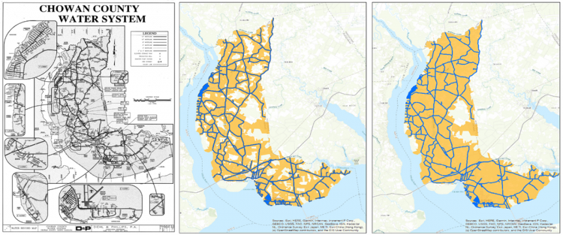

Figure 1: Schematic of water system map digitization process for analog water line maps

Table 1: Process to create the digital geospatial shapefile from different types of analog service area maps

|  |  |
| --- | --- |
| **Type of analog map** | **Process** |
| Water lines | Isolate water lines in Adobe Illustrator and add land parcels |
| Boundary | Trace boundary to create a polygon shapefile |
| Municipal boundary | Isolate boundary from statewide Census data |

**Lead Author Photograph**



**Sources**

MacDonald Gibson, J., & Pieper, K. J., 2017, “Strategies to Improve Private-Well Water Quality: A North Carolina Perspective.” *Environmental health perspectives*, 125(7), 076001. https://doi.org/10.1289/EHP890

New Jersey Department of Environmental Protection, 2019, “Public Community Water Purveyor Service Areas, New Jersey, Edition 20190211”.